**[Hair Fall Detection And Prevention System]**



**By:**

**Full Name – Dilawar Shah**

**35463**

**Full Name – Muhammad Talha Asghar**

**36673**

**Full Name – Noor Ullah Shah**

**35464**

**Supervised by:**

**[Sir Nadeem Khan]**

**Faculty of Computing** **Riphah International University, Islamabad** **Spring/Fall 2024**

**A Dissertation Submitted To**

**Faculty of Computing,**

**Riphah International University, Islamabad**

**As a Partial Fulfillment of the Requirement for the Award of the**

**Degree of**

**Bachelors of Science in Computer Science**

**Faculty of Computing** **Riphah International University, Islamabad**

Date: [date of final presentation]

**Final Approval**

This is to certify that we have read the report submitted by ***Dilawar Shah, Muhammad Talha Asghar, Noor Ullah Shah (35463, 36673, 35464)***, for the partial fulfillment of the requirements for the degree of the Bachelors of Science in Computer Science (BSSE). It is our judgment that this report is of sufficient standard to warrant its acceptance by Riphah International University, Islamabad for the degree of Bachelors of Science in Computer Science (BSSE).

**Committee:**

**1**

[Nadeem Khan]

(Supervisor)

**2**

[Dr Musharraf ]

(Head of Department/chairman)

**Declaration**

We hereby declare that this document “**[Hair Fall Detection And Prevention System]**” neither as a whole nor as a part has been copied out from any source. It is further declared that we have done this project with the accompanied report entirely on the basis of our personal efforts, under the proficient guidance of our teachers, especially our supervisor **[Sir Nadeem Khan]**. If any part of the system is proved to be copied out from any source or found to be reproduction of any project from anywhere else, we shall stand by the consequences.

**___________________________**

**[Noor Ullah Shah]**

**[35464]**

**___________________________**

**[M. Talha Asghar]**

**[36673]**

**___________________________**

**[Dilawar Shah]**

**[35464]**

**Dedication**

This project is dedicated to our family, friends and mentors whose constant support make us able to stand here today. To our Teachers, Professors and Supervisor thanks for sharing your knowledge and instilling a passion for learning in our mind.

Finally, we dedicate this project to those who work hard to make a positive impact on society through technology.

**Acknowledgement**

First of all we are obliged to Allah Almighty the Merciful, the Beneficent and the source of all Knowledge, for granting us the courage and knowledge to complete this Project.

[Students will acknowledge here anyone who has helped in the project. It can include Supervisor(s), Teachers, Classmates, Friends and Family]

**___________________________**

**[Noor Ullah Shah]**

**[35464]**

**___________________________**

**[M. Talha Asghar]**

**[36673]**

**___________________________**

**[Dilawar Shah]**

**[35463]**

**Abstract**

The Hair Loss Detection and Prevention System uses modern machine learning and image processing technology to provide a effective solution for early hair loss diagnosis and proactive hair care. Using Convolutional Neural Network (CNN) the system analyzes scalp photos to detect and categorize various phases of hair loss. Providing users, a personalized insight of their hair health. Integrated data augmentation techniques provide reliable, real-time identification of various scalp diseases, while personalized advice help users maintain and improve hair health. These advices include natural therapies, food guidelines and if necessary dermatological referrals, resulting in a comprehensive eco system for haircare. The system also provides a community-oriented approach by allowing users to share their progress and experience, therefore adding to a supporting network. A built-in dermatology network also recommends nearby specialists for those requiring professional help, increasing accessibility and ensuring that user obtain both preventing and ongoing care. This user-friendly program is intended to provide consumers with early identification and practical tools for managing their hair health over time

**Contents**

List of Tables ........................................................................................................................iii

List of Figures ....................................................................................................................... iv

Abstract 5

Chapter 1: Introduction 6

1.1 Goals and Objectives 6

Chapter 2: Literature Review 8

2.1 Introduction 8

2.2 Background and Problem Elaboration 8

2.3 Detailed Literature Review 8

2.3.1 Definitions 8

2.3.2 Related Research Work 1 9

2.3.3 Related Research Work 2 10

2.4 Literature Review Summary Table 11

2.5 Research Gap 14

2.6 Problem Statement 14

Chapter 3: Requirements and Design 16

3.1 Requirements 16

3.1.1 Functional Requirements 16

3.1.2 Non-Functional Requirements 16

3.1.3 Hardware and Software Requirements 17

3.2 Proposed Methodology 18

3.3 System Architecture 19

3.3.1 Input modules: 19

3.3.2 Pre-processing module: 20

3.3.3 Analysis module: 20

3.3.4 Recommendation Module 20

3.3.5 Community and support module 20

3.3.6 Output module 20

3.4 Use Cases 22

User: 22

3.4.1 Sample Use Case Name Here 25

Signup: 25

Chapter 4: Implementation and Test Cases 30

4.1 Implementation 30

4.1.1 Implementation of First Component/Algorithm 30

References 32

List of Tables

**List of Tables**

Table 1: This is Sample table caption ...................................................................................... 29

Table 2: This is Sample table caption ...................................................................................... 29

List of Figuresiv

**List of Figures**

Figure 1: List of Styles ............................................................................................................. 29

Figure 2: IEEE Reference style ................................................................................................ 30

# Abstract

The Hair Loss Detection and Prevention System uses modern machine learning and image processing technology to provide a effective solution for early hair loss diagnosis and proactive hair care. Using Convolutional Neural Network (CNN) the system analyzes scalp photos to detect and categorize various phases of hair loss. Providing users, a personalized insight of their hair health. Integrated data augmentation techniques provide reliable, real-time identification of various scalp diseases, while personalized advice help users maintain and improve hair health. These advices include natural therapies, food guidelines and if necessary dermatological referrals, resulting in a comprehensive eco system for haircare. The system also provides a community-oriented approach by allowing users to share their progress and experience, therefore adding to a supporting network. A built-in dermatology network also recommends nearby specialists for those requiring professional help, increasing accessibility and ensuring that user obtain both preventing and ongoing care. This user-friendly program is intended to provide consumers with early identification and practical tools for managing their hair health over time

# Chapter 1: Introduction

The Hair Loss Detection and Prevention System uses machine learning technology, specifically Convolutional Neural Networks (CNNs), to scan scalp images and reliably detect phases of hair loss. This system employs modern image processing and data augmentation techniques to provide dependable real-time results making it an effective solution for early hair loss detection and prevention.

The development of this technology includes not only detection but also personalized advice based on specific hair conditions. By analysing scalp photos, the device can determine the severity and pattern of hair loss and provide consumers with specialized care recommendations. These suggestions may include natural cures, dietary recommendations, and professional referrals, allowing users to make more informed decisions about their hair's health.

The platform also promotes community participation through social sharing, which allows users to share their experiences and progress with others. To provide thorough care, the system also provide location of nearby dermatologists to user, making professional aid available to individuals who require additional evaluation and treatment.

## 1.1 Goals and Objectives

The major purpose of the Hair Loss Detection and Prevention System is to provide an easy-to use and effective tool for early hair loss detection and preventative management. Objectives include:

* Creating a CNN-based algorithm capable of properly detecting and classifying hair loss phases using scalp photos.
* Implementing a personalized recommendation engine that will present users with practical information based on their individual hair concerns, such as natural therapies, diet, and dermatologist referrals.
* Enabling social sharing tools so that users can share their progress and build a supportive community.
* Creating a dermatologist network to enable professional consultations for users in need of advanced treatment.

**1.2 Scope of the Project**

* Analyse scalp images in real time.
* Detect hair fall through image processing.
* Provide recommendation system for personalized hair care.
* Features a user-friendly mobile application UI.
* Allowing users to connect with a network of nearby dermatologist.
* This app is only a supportive tool, not a replacement for medical advice.
* Targeted individual in the early to decrease stages of hair loss who seek for preventive measure and personalized care.

# Chapter 2: Literature Review

## 2.1 Introduction

The Hair Loss Detection and Prevention System uses machine learning technology, specifically Convolutional Neural Networks (CNN’s), to scan scalp images and reliably detect phases of hair loss. This system employs modern image processing and data augmentation techniques to provide dependable real-time results making it an effective solution for early hair loss detection and prevention.

The development of this technology includes not only detection but also personalized advice based on specific hair conditions. By analysing scalp photos, the device can determine the severity and pattern of hair loss and provide consumers with specialized care recommendations. These suggestions may include natural cures, dietary recommendations, and professional referrals, allowing users to make more informed decisions about their hair's health.

The platform also promotes community participation through social sharing, which allows users to share their experiences and progress with others. This feature promotes a supportive environment by allowing users to track their own progress. To provide thorough care, the system also connects users with nearby dermatologists, making professional aid available to individuals who require additional evaluation and treatment.

## 2.2 Background and Problem Elaboration

Hair loss affects millions of people worldwide, and the causes range from genetics and aging to stress and environmental factors. While hair loss is common, it can have a substantial impact on a person's and mental health. Despite the availability of different therapies and treatments, most individuals are unaware of the initial signs of hair loss and the individualized solutions that are best suited to their particular condition. As a result, there is a need for an accessible, user-friendly system that can detect early signs of hair loss and provide practical advice to consumers. That is what we are creating in this project.

## 2.3 Detailed Literature Review

### 2.3.1 Definitions

The Hair Loss Detection and Prevention System uses machine learning technology, specifically Convolutional Neural Networks (CNNs), to scan scalp images and reliably detect phases of hair loss. This system employs modern image processing and data augmentation techniques to provide dependable real-time results making it an effective solution for early hair loss detection and prevention

### 2.3.2 Related Research Work 1

The paper (Machine Learning Based KNN Method for Stress Based Hair Fall Detection and Prevention) focuses the use of machine learning approaches, such as the K-Nearest Neighbors (KNN) algorithm, to identify and categorize hair problems. KNN, which depends on features retrieved from scalp images such as texture, shape, and color, has reached a commendable 91.4% accuracy. However, it falls short when it comes to identifying complicated patterns, which is where advanced techniques such as Convolutional Neural Networks (CNNs) shine. Your project's usage of CNNs provides a more sophisticated and accurate solution to this difficulty.

Stress has been defined as a major factor to hair loss, particularly in demanding professions. The article emphasizes the necessity of early detection methods, since untreated hair loss can lead to more serious scalp and hair health problems. Stress has been defined as a major factor to hair loss, particularly in demanding professions. The article emphasizes the necessity of early detection methods, since untreated hair loss can lead to more serious scalp and hair health problems. This is consistent with our project's goal of offering immediate assistance via scalp image analysis and targeted suggestions, ensuring users receive the care they require before conditions get worsen.

The study focuses on several essential factors of dataset usage.

* Using many data sets to properly train machine learning model.
* To increase the quality of input data, use pre-processing techniques such as noise reduction and picture enhancement.
* KNN classifications are based on similarity measurements like Euclidean distance. These tactics are useful insights for our CNN-based project because they optimize the input data for improved model performance.

The paper provides many areas for further exploration.

* Creating hybrid models that combine the simplicity of KNNs with the advanced capabilities of CNNs to increase prediction accuracy.
* Incorporating user feedback to improve model reliability and usability.
* Expanding datasets that include a more diverse population, ensuring that the system is globally applicable and suitable for a wider range of users.

### 2.3.3 Related Research Work 2

This study proposes an AI-powered solution to the issues of identifying hair and scalp conditions. Hair loss, which is typically caused by illnesses such as alopecia, psoriasis, and folliculitis, can have a significant impact on a person's confidence and quality of life. Diagnosis is frequently delayed due to the necessity for specialist examination, which leads to deteriorating conditions. Using advances in machine learning and image processing, the scientists created a deep learning-based model that automates disease identification and aids in early intervention. Their research focuses on the use of Convolutional Neural Networks (CNNs) to categorize scalp illnesses based on visual data, addressing a major gap in accessible and efficient diagnostic tools.

**Key contribution:**

* **Focus:**

The study aims to detect three primary hair and scalp diseases: alopecia, psoriasis, and folliculitis. These disorders were chosen based on their prevalence and influence on hair quality.

* **Technology Used:**

Two-dimensional convolutional neural networks (CNNs) were used to classify hair disorders. CNNs were chosen because they can extract useful features from raw picture data with little human intervention.

The model had a training accuracy of 96.2% and a validation accuracy of 91.1 percent.

* **Dataset:**

The dataset used in this study included 150 scalp images divided into three categories: 65 for alopecia, 45 for psoriasis, and 40 for folliculitis. These photographs were obtained from online dermatological platforms such as DermQuest, DermNet and MedicineNet. Furthermore, conversations with medical professionals helped to enrich the dataset, guaranteeing a wide representation of illnesses.

* **System architecture:** To examine nonlinear interactions between input and output variables, the convolutional neural network (CNN) model was constructed with three hidden layers, a softmax output layer, and a ReLU activation function. To avoid overfitting, dropout layers at a 30% rate were added after the pooling layers. To reduce input dimensions, the model used pooling layers with a 2x2 kernel size, and the Adam optimizer was used to improve learning efficiency. Using the processed characteristics, the final model sorted input photos into three unique categories.
* **Challenges Addressed:** The study addressed numerous major issues, including data scarcity, which was addressed by developing a publicly accessible dataset to aid future research. Image quality variability caused by changes in resolution, texture, and color was reduced using advanced preparation techniques. Furthermore, inter-class similarities that could impede accurate classification were addressed by using a strong model architecture and a balanced dataset.
* **Results:** The algorithm produced high precision and recall scores for all three types of scalp disorders. The precision and recall for alopecia were both 0.895, while psoriasis had values of 0.846. Folliculitis obtained flawless precision and recall ratings of 1.0. These measurements, depicted in a confusion matrix, demonstrate the model's dependability and accuracy for early-stage disease detection.
* **Applications:** This approach has great potential applications in dermatology, as it benefits both patients and professionals. By automating the classification of scalp problems, the system allows for early detection and treatment of hair and scalp-related diseases, increasing patient outcomes and eliminating diagnostic delays.

## 2.4 Literature Review Summary Table

**Table 1: Literature review**

*This table represents literature review of 2 paper related to our project.*

|  |  |  |  |  |  |  |
| --- | --- | --- | --- | --- | --- | --- |
| **No.** | **Name, reference** | **Inventor** | **Year** | **Input** | **Output** | **Description** |
| 1. | Machine Learning  Based KNN Method  for Stress Based Hair  Fall Detection and  Prevention,  [Munagala Adi  Lakshmi, Radhika,  Sadineni Rama Rao,  2024] | Munagala Adi  Lakshmi, Radhika,  Sadineni Rama Rao | 2024 | Scalp images, hair texture,  shape, and color features | Hair loss classification (healthy hair, alopecia areata, psoriasis, diverticulitis) | The research describes a system that uses the KNearest  Neighbors  (KNN)  algorithm to identify and classify stressinduced hair loss. It analyzes scalp  images for texture, shape, and color to provide early detection and individualized care suggestions. |
| 2. | Hair and Scalp Disease Detection using Machine Learning and Image  Processing,  [Mrinmoy Roy, Anica  Tasnim Protity,  European Journal of  IT and CS, Vol. 3, Issue 1, January 2023, DOI: 10.24018/ejcompute.2  023.3.1.85] | Mrinmoy Roy,  Anica Tasnim  Protity | 2023 | Scalp images processed through  denoising,  CLAHE, and  data augmentation | Classification of scalp conditions (alopecia, psoriasis, folliculitis) | This paper uses a 150image dataset  to create a  CNN-based system for classifying three hair and scalp-related disorders. The system uses pre-processing approaches to improve image quality and achieve consistent classification accuracy. |

## 2.5 Research Gap

Hair loss is a widespread issue affecting millions of people worldwide, with causes ranging from genetic predisposition and hormone imbalances to stress and environmental exposure. Despite its wide influence, there are substantial gaps in current solutions to this problem. Many people have delays in detecting hair loss or related scalp disorders due to a lack of dermatologists and accessible diagnostic instruments. Furthermore, existing diagnostic procedures are frequently reactive, emphasizing treatment after severe hair loss has occurred rather than proactive attempts for early identification and prevention.

Another important gap is the lack of individualized solutions tailored to specific needs. Scalp type, hair texture, lifestyle behaviours, and dietary deficiencies are all important factors in hair health, but they are rarely taken into account by present methods. Furthermore, technology advancements, such as AI-powered picture analysis, have not been fully integrated to give consumers with accurate, real-time insights.

There is also a lack of community support and awareness, leaving individuals without the resources of sharing stories, track progress, or seek comprehensive guidance. Professional consultations, when offered, are sometimes unavailable or expensive, creating hurdles to timely and efficient treatment. These limitations highlight the need for a comprehensive, technology driven system that not only detects hair loss early on but also offers individualized preventative techniques, encourages community engagement, and closes the gap between users and professional treatment.

## 2.6 Problem Statement

Hair loss is a major condition that affects millions of people worldwide, with causes ranging from hereditary factors and hormonal imbalances to environmental influences and stress. Despite the fact that it occurs, early detection and prevention of hair loss remain significant challenges. Existing treatments primarily manage visible hair loss, which sometimes requires expensive, time-consuming, and inaccessible expert consultations for many people. Furthermore, these systems often lack individualization, failing to take into account individual factors such as scalp type, lifestyle patterns, and nutritional habits.

This study addresses these issues by developing a comprehensive AI-powered system that use Convolutional Neural Networks (CNNs) to predict hair loss stages via scalp picture analysis. It combines detection with practical prevention methods, such as nutritional and lifestyle suggestions, community participation through social sharing, and professional referrals, to provide an accessible, individualized, and comprehensive approach to managing hair loss.

# Chapter 3: Requirements and Design

Describe all modules of requirements and design in clear English text along with the necessary diagram and figures. Anyone reading your report should be able to reproduce your system/results after reading it.

## 3.1 Requirements

The Requirements Chapter outlines the important specifications for system development. It is divided Into two sections: functional requirements and non-functional requirements.

### 3.1.1 Functional Requirements

**User:**

|  |  |
| --- | --- |
| ID | Requirements |
| FR 1.1 | User shall be able to sign up. |
| FR 1.2 | User shall be able to login. |
| FR 1.3 | User should upload images of their scalp for analysis. |
| FR 1.4 | User will be able to take photo directly. |
| FR 1.5 | User will be able to see result of their hair loss analysis. |
| FR 1.6 | User can be received recommendation. |
| FR 1.7 | User can share their experience with others. |
| FR 1.8 | User can check their nearby dermatologist location. |

**Admin:**

|  |  |
| --- | --- |
| ID | Requirements |
| FR 2.1 | Admin shall be able to login to the system. |
| FR 2.2 | Admin can manage user accounts. |
| FR 2.3 | Admin shall be able to monitor app. |

**System:**

|  |  |
| --- | --- |
| ID | Requirements |
| FR 3.1 | System classify hair fall stages and provide result. |
| FR 3.2 | System will give recommendation. |
| FR 3.3 | System will store images and other information of users. |
| FR 3.4 | System will provide community support group. |
| FR 3.5 | System will provide location of dermatologist |

### 3.1.2 Non-Functional Requirements

* **User Friendly interface:** the app has a very friendly interface and easy to use. users can navigate easily and can easily access their desired feature
* **Compatibility:** The System is compatible with multiple android devices.
* **Performance:** the system is very reliable and consistently performing well.

### 3.1.3 Hardware and Software Requirements

**Hardware Requirements:**

* **Smartphone:** Smart Phones that support Android (8.0 or above) and have at least 2GB of RAM and sufficient processing power for handling users’ requests.
* **Internet connectivity:** Reliable internet (4G or 5G) or broadband for accessing real-time of application.
* **Storage:** A sufficient storage space to upload images, user profiles and users sharing experience or comments.
* **Display Resolution:** A Smart phone will have minimum 720p screen resolution.

**Software Requirements:**

* **Operating System:** 
  + For development the suitable operating system will be windows (10/11), or Linux (Ubuntu).
* **Programming languages:**

Following are the languages:

* + Python is used in model training with the following libraries and framework.
  + Machine Learning & Deep Learning:
    - TensorFlow (Keras)
    - Scikit-learn
  + Data processing:
    - NumPy
    - Pandas
    - Matplotlib
    - Seaborn
  + Dart for flutter app frontend.
* **IDE:** 
  + Android studio for flutter app development.
  + Google collab for machine learning model training.
* **Database:** 
  + In database we will use firebase for storing user data, messages or comment and images.
* **Other tools:** 
  + we use GitHub for version control

## 3.2 Proposed Methodology

The Hair Loss Detection and Prevention System is a smartphone application that helps users identify hair loss phases and provides individualized care recommendations. The system uses AI and machine learning technology to provide real-time detection and recommendations based on individual needs. It is designed to assist those worried about their hair's health by providing accurate information and community-based support.

The app allows users to upload scalp images for analysis. It uses CNN models to evaluate these photos and determine different phases of hair loss. Based on the identification, the system offers consumers personalized recommendations such as diet changes, natural cures, and expert referrals. To provide a user-friendly experience, we intend to build the system as a mobile application with real-time capabilities.

We are developing this using machine learning technology. We collect a large set of image data, then apply an augmentation technique to increase dataset diversity and prevent overfitting. Finally, we use Convolutional Neural Networks (CNN), which are well-suited for image classification tasks. on the huge dataset, which provide rather excellent results

To increase user engagement, the app features a social sharing function that allows them to share their progress and connect with others. It also contains a local dermatologist network; the app will refer users to nearby dermatologists if their condition worsens.

Figure 1: Proposed methodology

 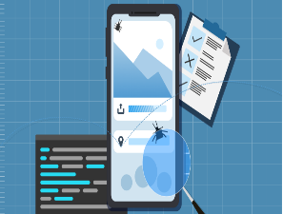 

**Deployment**

**Testing**

**Integration**



  

**Data Collection**

**App Development**

**ML Model Trainning**

## 3.3 System Architecture

The system architecture of the Hair Loss Detection and Prevention system is intended to give users with a straightforward and effective method for detecting and managing hair loss issues. This architecture utilizes modern machine learning techniques, user-friendly interfaces, and smooth data processing pipelines to enable precise identification and individualized suggestions. The system is made up of multiple modules, such as input, preprocessing, analysis, suggestions, community support, professional integration, and output layers, all of which are designed to work together to deliver a dependable and comprehensive user experience.

### 3.3.1 Input modules:

This module serves as the system's entry point, allowing users to upload high-resolution scalp pictures from their mobile devices. Camera integration, for example, makes it possible to shoot images seamlessly.

### 3.3.2 Pre-processing module:

This module analyses the scalp photos in a series of stages to guarantee that the input data is standardized and acceptable for analysis. Denoising filters are used to eliminate unwanted noise while saving vital features. Data augmentation techniques such as rotation, flipping, and cropping are used to diversify the dataset and make the system adaptive to changes in input. Pre-processing activities are performed using Python packages like as OpenCV and TensorFlow.

### 3.3.3 Analysis module:

The analysis module is at the very core of the system, detecting and classifying different stages of hair loss using a Convolutional Neural Network (CNN). The CNN, which was trained on a broad dataset of scalp photos, recognizes patterns such as early-stage thinning, moderate hair loss, and advanced baldness. This module is based on deep learning frameworks such as TensorFlow or PyTorch, with pretrained models such as Alpha net fine-tuned to specialize in hair loss detection.

### 3.3.4 Recommendation Module

Based on the analysis module's results, this module provides personalized advise based on the user's hair condition and additional demographic information. To delay or reverse hair loss, suggestions may include dietary changes, stress management strategies, and natural therapies. The system uses rule-based decision logic to ensure that the recommendations are specific and actionable, providing a more tailored approach to hair care and prevention.

### 3.3.5 Community and support module

To increase user engagement, this module allows them to track and share their progress via social sharing tools. It also serves as a platform for community interaction, allowing users to share tips, discuss their experiences, and seek assistance from others who share similar issues. Backend frameworks like as Firebase provide real-time interaction, resulting in a user-friendly environment.

### 3.3.6 Output module

The last module presents the results and recommendations in a user-friendly way. Text-based advice for the next actions. This module guarantees that users can understand and use the system's findings, making hair care management more effective and accessible. The interactive displays are powered by frontend technologies such as React.js and Flutter, which ensure a seamless user experience.

Figure 2: System architecture

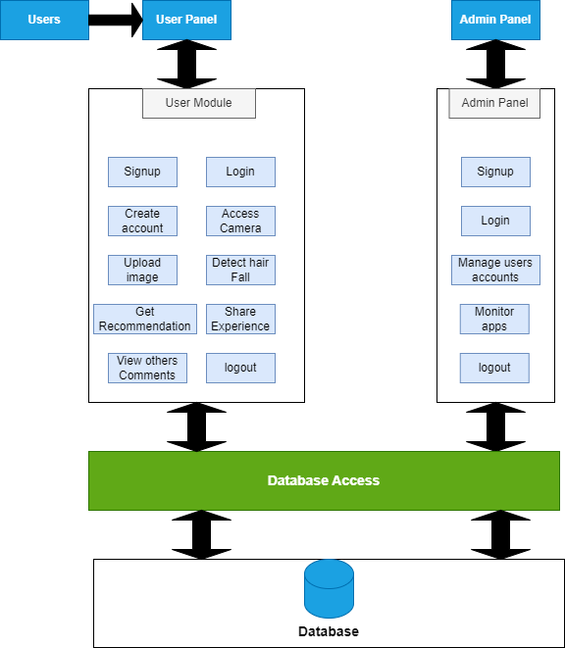

## 3.4 Use Cases

### User:

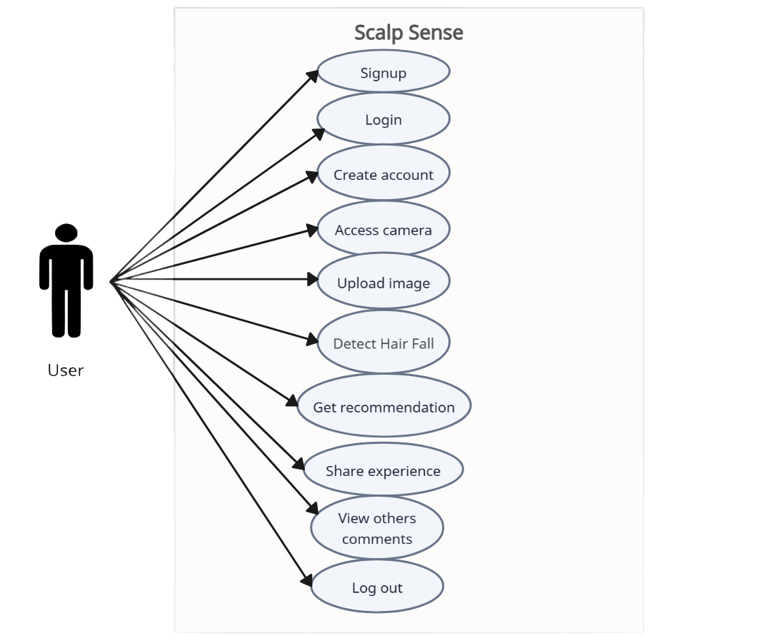

### Admin:

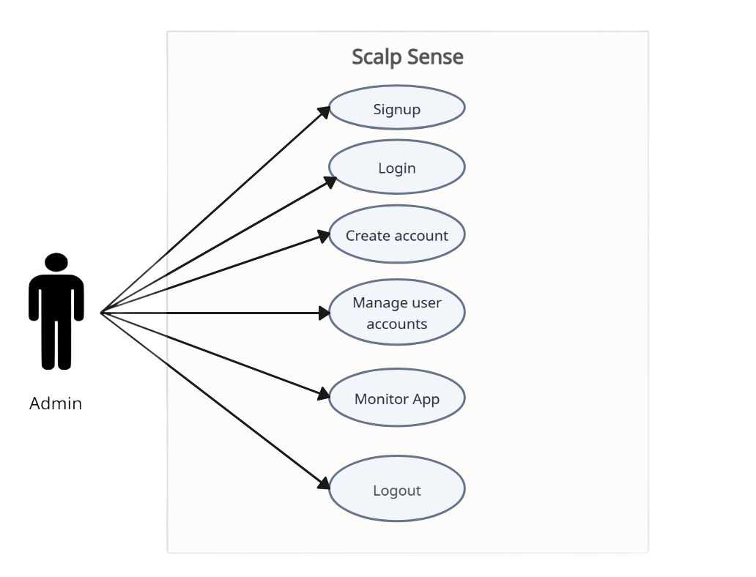

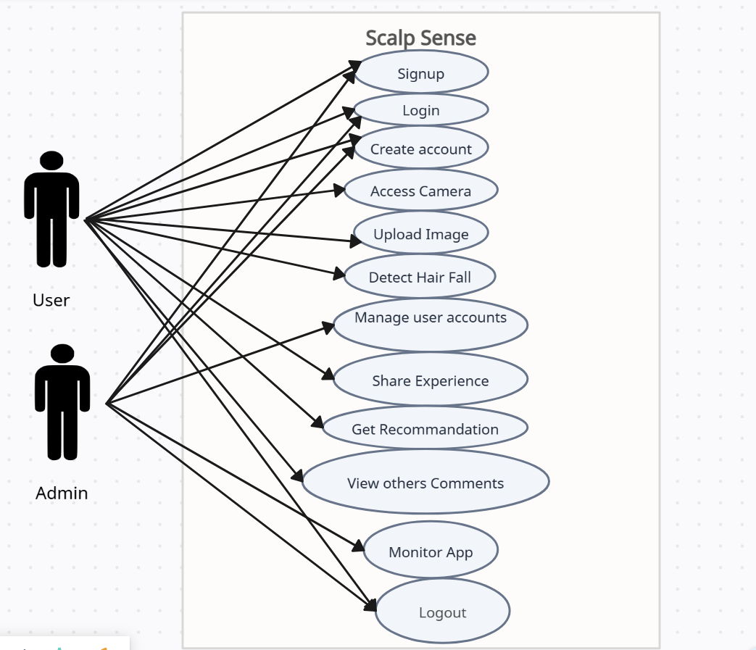

### 3.4.1 Sample Use Case Name Here

**Fully Dressed Use cases:**

**Signup:**

|  |  |  |  |  |
| --- | --- | --- | --- | --- |
| **Name** | | Sign Up | | |
| **Actors** | | User. | | |
| **Summary** | | The system allows users to create new account by providing new information. | | |
| **Pre-**  **Conditions** | | None. | | |
| **Post-**  **Conditions** | | A new account will be created and users can log in to the system. | | |
| **Special**  **Requirements** | | None. | | |
| **Basic Flow** | | | | |
|  | **Actor Action** | | **System Response** | |
| 1 | The user opens the app. | | 2 | The signup page is displayed asking for email and password. |
| 3 | The user enters email and password. | | 4 | The system create account and show message “Account is created”. |
|  | **Alternative Flow** | | | |
| 3 | If the user enters incomplete information. | | 4-A | The system responds with an error message indicating “incomplete or invalid credential”. |

**Login:**

|  |  |  |  |  |
| --- | --- | --- | --- | --- |
| **Name** | | Login | | |
| **Actors** | | Admin, User. | | |
| **Summary** | | The users (Admin, user) should enter their email and password in the login form and after successful verification user will be get access to the home page. | | |
| **Pre-**  **Conditions** | | User must have account before login. | | |
| **Post-**  **Conditions** | | After login user will be redirected to the home page of the app. | | |
| **Special**  **Requirements** | | None | | |
| **Basic Flow** | | | | |
|  | **Actor Action** | | **System Response** | |
| 1 | The user opens the login page. | | 2 | The login page is displayed asking for email and password. |
| 3 | The user enters valid email and password. | | 4 | The system verifies the email and password, establishes a session for the user and redirects the user to the home page. |
|  | **Alternative Flow** | | | |
| 3 | The user enters invalid email or password. | | 4-A | The system responds with an error message: *Incorrect email or password entered.* |

**Upload Image:**

|  |  |  |  |  |
| --- | --- | --- | --- | --- |
| **Name** | | Upload image | | |
| **Actors** | | User. | | |
| **Summary** | | The user will upload image from their gallery through the home page of app. | | |
| **Pre-**  **Conditions** | | User must be login and have access to home page. | | |
| **Post-**  **Conditions** | | Picture will be uploaded for processing. | | |
| **Special**  **Requirements** | | Image of Scalp. | | |
| **Basic Flow** | | | | |
|  | **Actor Action** | | **System Response** | |
| 1 | The user opens the home page. And click on the “Select image” button | | 2 | The pop-up appears and will ask for image source. |
| 3 | The user clicks on gallery and select the image and click on add button | | 4 | The image is uploaded now the system will process it. |
|  | **Alternative Flow** | | | |
| 3 | The user clicks on the “Select Button” and then click cancel. | | 4-A |  |

**Take picture:**

|  |  |  |  |  |
| --- | --- | --- | --- | --- |
| **Name** | | Take Picture | | |
| **Actors** | | User. | | |
| **Summary** | | The user will upload image to the system using their mobile phone camera. | | |
| **Pre-**  **Conditions** | | User must be login and have access to home page. | | |
| **Post-**  **Conditions** | | Picture will be uploaded for processing. | | |
| **Special**  **Requirements** | | Image must be of Scalp. | | |
| **Basic Flow** | | | | |
|  | **Actor Action** | | **System Response** | |
| 1 | The user opens the home page. And click on the “Select image” button | | 2 | The pop-up appears and will ask for image source. |
| 3 | The user clicks on “Camera” and take picture to upload. | | 4 | The image is uploaded now the system will process it. |
|  | **Alternative Flow** | | | |
| 3 | The user clicks on the “Select Button” and then click cancel. | | 4 |  |

**Hair Fall Detection:**

|  |  |  |  |  |
| --- | --- | --- | --- | --- |
| **Name** | | Hair Fall Detection | | |
| **Actors** | | User. | | |
| **Summary** | | The user will upload an image of their scalp, and the system will identify it according to the stage the user's hair is in. | | |
| **Pre-**  **Conditions** | | User must be login and have access to home page. | | |
| **Post-**  **Conditions** | | Result will come out. | | |
| **Special**  **Requirements** | | Image of Scalp. | | |
| **Basic Flow** | | | | |
|  | **Actor Action** | | **System Response** | |
| 1 | The user upload image of the scalp. | | 2 | The system display “Show detected result”  Button. |
| 3 | The user clicks on the “Show detected result” Button. | | 4 | The system displays the result of the user scalp. |
|  | **Alternative Flow** | | | |
| 3 | The user upload image other than scalp. | | 4-A | The system shows error message “Invalid input”. |

**Share Experience:**

|  |  |  |  |  |
| --- | --- | --- | --- | --- |
| **Name** | | Share experience | | |
| **Actors** | | User. | | |
| **Summary** | | The user can share their experience with the app in community support group | | |
| **Pre-**  **Conditions** | | User must be login and have access to home page. | | |
| **Post-**  **Conditions** | | Other member can get the idea about the app | | |
| **Special**  **Requirements** | | None | | |
| **Basic Flow** | | | | |
|  | **Actor Action** | | **System Response** | |
| 1 | The user login to the home page and clicks on the community support group icon from bottom navigation bar | | 2 | The system displays the group where user can share the experience. |
| 3 | The user writes their experience and clicks on send button icon. | | 4 | The message is sent and other members can see it. |

**View other comments:**

|  |  |  |  |  |
| --- | --- | --- | --- | --- |
| **Name** | | Share experience | | |
| **Actors** | | User. | | |
| **Summary** | | The user can view the shared experience of other peoples and can get some advices. | | |
| **Pre-**  **Conditions** | | User must be login and have access to home page. | | |
| **Post-**  **Conditions** | | User will get any advice | | |
| **Special**  **Requirements** | | None | | |
| **Basic Flow** | | | | |
|  | **Actor Action** | | **System Response** | |
| 1 | The user login to the home page and clicks on the community support group icon from bottom navigation bar | | 2 | The system displays the group where users can share the experience or advice and saw others messages. |
| 3 | The user will saw the messages or comments of other peoples. | | 4 |  |

**Get recommendation:**

|  |  |  |  |  |
| --- | --- | --- | --- | --- |
| **Name** | | Get recommendation | | |
| **Actors** | | User. | | |
| **Summary** | | The user will upload an image of their scalp, and the system will identify his hair fall stage and will provide recommendation according to their hair conditions. | | |
| **Pre-**  **Conditions** | | User must upload image of their scalp. | | |
| **Post-**  **Conditions** | | User can see the recommendation given by system. | | |
| **Special**  **Requirements** | | Image of Scalp. | | |
| **Basic Flow** | | | | |
|  | **Actor Action** | | **System Response** | |
| 1 | The user upload image of the scalp. | | 2 | The system display “Show detected result”  Button. |
| 3 | The user clicks on the “Show detected result” Button. | | 4 | The system displays the result of the user scalp and provide recommendation. |
| 5 | User can see recommendation given by system. | |  |  |
|  | **Alternative Flow** | | | |
| 3 | The user upload image other than scalp. | | 4-A | The system shows error message “Invalid input”. |

**Logout:**

|  |  |  |  |  |
| --- | --- | --- | --- | --- |
| **Name** | | logout | | |
| **Actors** | | Admin, User. | | |
| **Summary** | | The users (Admin, user) can logout from the system if they want. | | |
| **Pre-**  **Conditions** | | User must be login to the system. | | |
| **Post-**  **Conditions** | | Users will be logout and will have no access to homepage.. | | |
| **Special**  **Requirements** | | None | | |
| **Basic Flow** | | | | |
|  | **Actor Action** | | **System Response** | |
| 1 | The users click on the menu in bottom navigation bar. | | 2 | The system displays a pop up. |
| 3 | The user clicks on logout. | | 4 | The system logout the user and navigate him to sigh in screen. |

# Chapter 4: Implementation and Test Cases

## 4.1 Implementation

### 4.1.1 Implementation of First Component/Algorithm

**Dataset Management:**

The code begins with dataset management, which involves integrating Google Drive to retrieve and store essential files and outputs. The dataset, which is stored as a compressed zip file, is extracted to a specified directory. Once extracted, the implementation collects all picture file paths and labels, which are derived from the names of the subdirectories where the images are located. Following that, the dataset is divided into two subsets: training (80%) and testing (20%), with labels stratified. The split data is next organized into directories for training and testing, with subfolders created for each label category.

**Data Augmentation:**

To improve the model's generalization capabilities, data augmentation techniques are used on the training dataset. These methods include rescaling pixel values to normalize image data, as well as transformations like rotation, width and height shifts, shear, zoom, and horizontal flips. These augmentations imitate changes in the dataset, allowing the algorithm to acquire more robust characteristics for detecting hair loss.

**Model Design:**

The implementation leverages both pretrained deep learning models and custom convolutional neural networks (CNNs) for feature extraction and classification. Pretrained models such as ResNet50V2 and DenseNet169, are used as base feature extractors, and their outputs are connected to fully connected layers for fine-tuning the models on the specific dataset. In addition to pretrained models, a custom CNN is built from scratch with convolutional layers for feature extraction, pooling layers to reduce spatial dimensions, and fully connected layers to perform classification. These architectures are designed to efficiently process scalp images and predict different stages of hair loss.

**Model training:**

The Adam optimizer is used in the training process, which dynamically adapts the learning rate, as well as categorical crossentropy loss for multi-class classification. Training metrics, such as accuracy and loss, are monitored across epochs for both training and validation data. To improve the training process, callbacks such as early stopping and learning rate reduction on the validation loss plateau are used. Early stopping reduces overfitting by interrupting training when validation loss no longer improves, whereas learning rate reduction adjusts the learning rate in order to boost convergence when the model approaches a plateau.

**Performance evaluation:**

The model's performance is measured using a range of metrics, including precision, recall, F1-score, and accuracy. These metrics are calculated on the validation and test datasets, providing insight into how effectively the model generalizes to new data. A classification report is generated, and the results are represented using confusion matrices, which provide a thorough perspective of the model's predictions for each class. Additional visualizations include plotting training and validation accuracy and loss over epochs, which can help in analysing model improvements and detecting potential overfitting or underfitting concerns.

**Model Saving:**

To save the trained model for future use, the implementation saves its weights and parameters to Google Drive. This ensures that the trained model may be easily reloaded for further testing, evaluation, or deployment without requiring retraining.

**Testing:**

Finally, the trained model is tested on unseen data to validate its real-world performance. The evaluation metrics and results are documented, and detailed visualizations such as plots and confusion matrices are generated to provide a comprehensive analysis of the model's capabilities. These reports help in fine-tuning the model and understanding its strengths and areas for improvement.

# References

1. Munagala, A. L., Radhika, M., & Rama Rao, S. (2024). **Machine Learning Based KNN Method for Stress Based Hair Fall Detection and Prevention.** ZKG International, Volume IX, Issue I, June 2024, ISSN: 2366-1313. Retrieved from [www.zkginternational.com](http://www.zkginternational.com).
2. Roy, M., & Protity, A. T. (2023). Hair and Scalp Disease Detection using Machine Learning and Image Processing. European Journal of Information Technologies and Computer Science, 3(1), 7–13. DOI: [10.24018/ejcompute.2023.3.1.85](http://dx.doi.org/10.24018/ejcompute.2023.3.1.85)
3. Sayyad, S., Midhunchakkaravarthy, D., & Sayyad, F. (2022). An Analysis of Alopecia Areata Classification Framework for Human Hair Loss Based on VGG-SVM Approach. Journal of Pharmaceutical Negative Results, 13(Special Issue 1), 9–14. DOI: 10.47750/pnr.2022.13.S01.02